Cohort-Aware Evaluation for Stroke Prediction Models

1. Background and Motivation
Stroke prediction using pre-hospital or early clinical information is inherently challenging due to substantial heterogeneity in patient presentation. Differences in symptom severity, physiological measurements, and clinical context can lead to varying levels of predictability across patient subpopulations. As a result, evaluating a single predictive model on the entire population may obscure meaningful structure in the data and mask important differences in model behavior across subsets of patients.
To better understand how model performance varies across heterogeneous subpopulations, and to assess system-level performance under a cohort-aware evaluation framework, we conducted a structured analysis based on receiver operating characteristic (ROC) curves and area under the curve (AUC) metrics. This analysis compares a convention
al baseline modeling strategy with a cohort-partitioned and routed evaluation strategy.

2. Baseline Evaluation on the Full Dataset
As a reference, baseline performance was established by training and evaluating three standard model types—a neural network (NN), a random forest (RF), and a gradient-boosted tree model (XGB)—on the full dataset without any cohort partitioning. All models were evaluated on a fixed held-out test set, treating stroke as the positive class.
Baseline ROC curves and corresponding AUC values summarize the discriminative performance obtained under the assumption of a homogeneous population. These results represent the performance that would be observed under a conventional modeling approach in which all samples are treated uniformly.

3. Identification of a High-Consistency Subset via Gravitational Clustering
To explore heterogeneity within the dataset, we applied a gravitational clustering–based procedure to organize samples into subsets with greater internal consistency. This process identified a “best-performing” cluster, defined as a subset of samples for which model discrimination between stroke and non-stroke cases was consistently strong across model types.
The clustering procedure was applied independently of model training and evaluation and served solely as a data-driven mechanism for cohort construction. No outcome-based filtering was performed during clustering; rather, clustering was used to partition the dataset into more homogeneous subpopulations based on feature structure.

4. Cohort-Specific Evaluation: Best and Remaining Subsets
Following cohort construction, model performance was evaluated separately on two disjoint subsets of the test data:
(1) the best-performing cohort identified through gravitational clustering, and
(2) the remaining cohort, consisting of all test samples not included in the best-performing subset.
For each cohort, the same three model types (NN, RF, and XGB) were trained and evaluated using the same fixed train–test split as in the baseline evaluation. ROC curves for these cohort-specific evaluations illustrate differences in discriminative behavior across subsets and provide insight into how predictability varies across the population.

5. Combined (Routed) Evaluation at the System Level
While cohort-specific evaluations provide insight into subpopulation behavior, practical deployment requires a single system-level prediction for each incoming sample. To simulate this setting, a combined (routed) evaluation was performed.
In this combined evaluation, test samples belonging to the best-performing cohort were scored using models trained on that cohort, while samples belonging to the remaining cohort were scored using models trained on the remaining subset. The resulting predictions were then aggregated to produce a single set of scores over the full held-out test set. ROC curves and AUC values computed from these aggregated scores reflect overall system-level performance under a cohort-aware routing strategy.

6. Summary of Performance Across Modeling Strategies
Table X summarizes ROC–AUC values across baseline, cohort-specific, and combined routed evaluations for all three model types. Across models, performance within the best-performing cohort is substantially higher than performance within the remaining cohort, indicating marked heterogeneity in outcome separability across subsets of the data.
When predictions from the best-performing and remaining cohorts are combined through cohort-based routing, overall system-level performance differs from the baseline evaluation conducted on the full dataset without cohort partitioning. These results demonstrate that explicitly accounting for cohort structure can alter observed performance metrics at the system level compared with a homogeneous baseline evaluation.
7. Interpretation and Implications
Taken together, the ROC analyses and AUC summaries illustrate that a single global evaluation may obscure meaningful structure within the data. By separating a high-consistency subset from the remaining samples and recombining predictions through routing, the modeling strategy explicitly accounts for population heterogeneity while preserving a unified system-level output.
This cohort-aware evaluation framework provides a principled basis for model selection and for determining which system-level ROC curve is most representative for external-facing communication and poster presentation.
8. Transition to External-Facing Evaluation
Based on these findings, subsequent analyses focus on selecting a single ROC curve from the combined routed evaluation that best represents overall system performance for external communication and poster development.

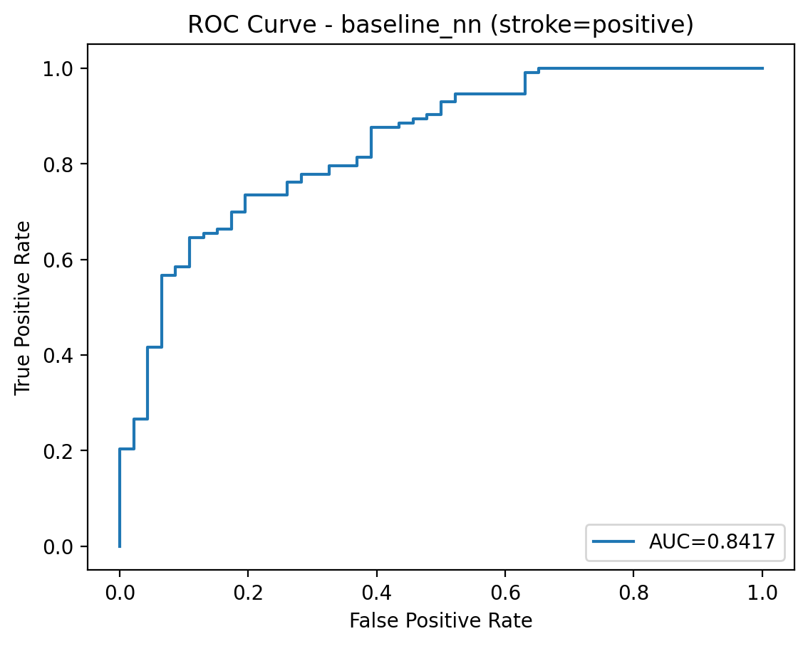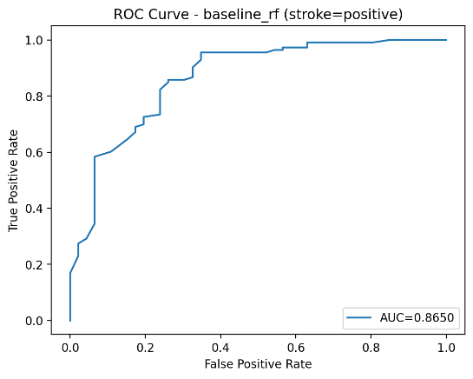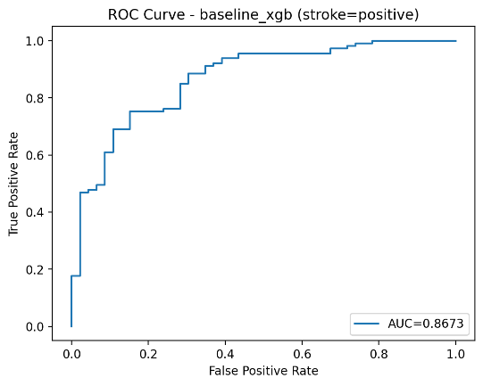
Figure 1. Receiver Operating Characteristic (ROC) Curves for Baseline Models.
Receiver operating characteristic (ROC) curves for baseline stroke prediction models evaluated on a held-out test set. The three panels show results for a neural network (NN), a random forest (RF), and a gradient-boosted tree model (XGB), respectively. Stroke is treated as the positive class in all evaluations. ROC curves are generated by varying the decision threshold applied to continuous model prediction scores, and the area under the curve (AUC) is reported on each panel.

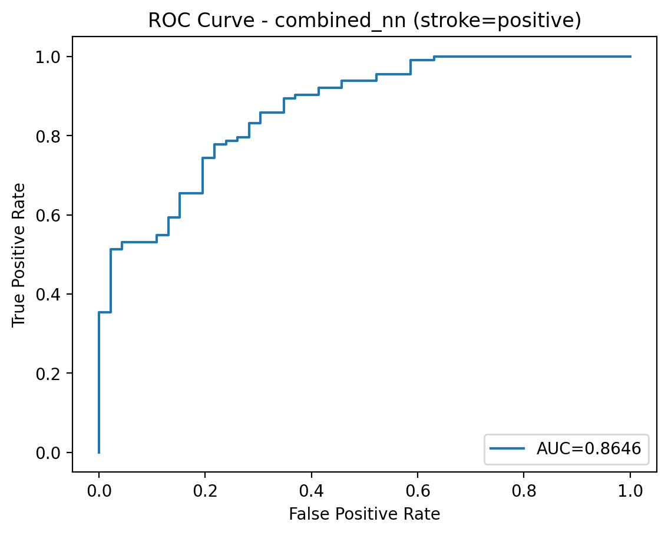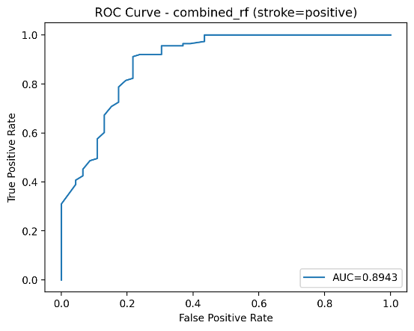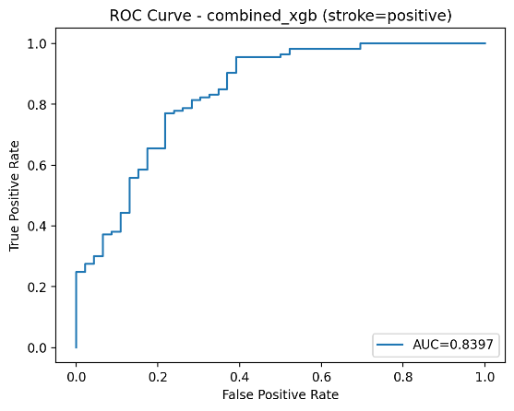
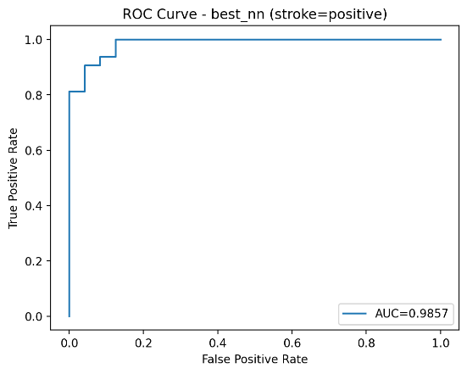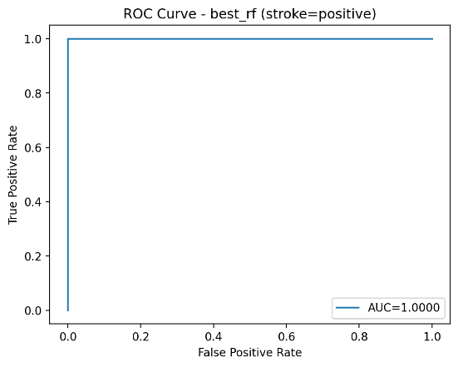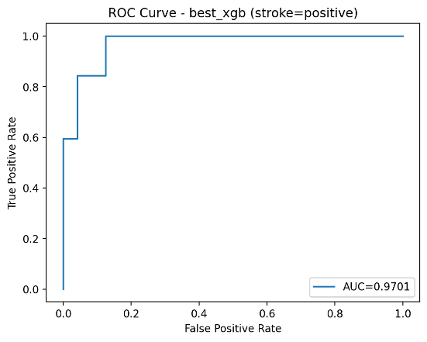
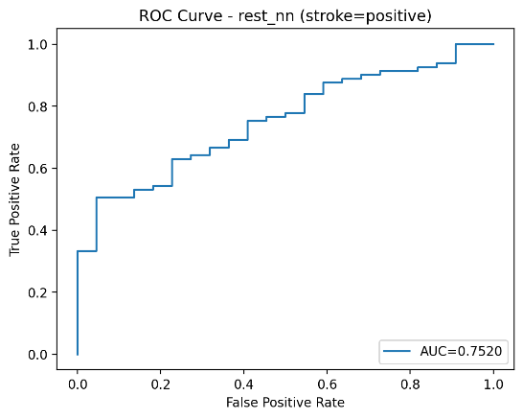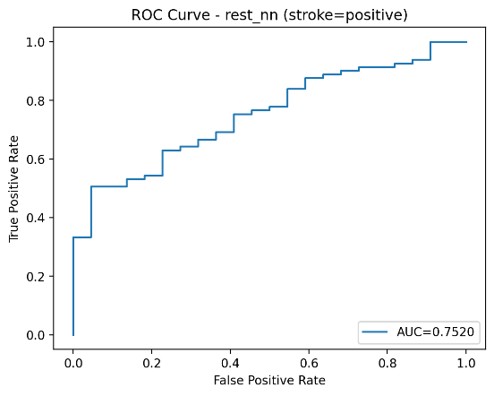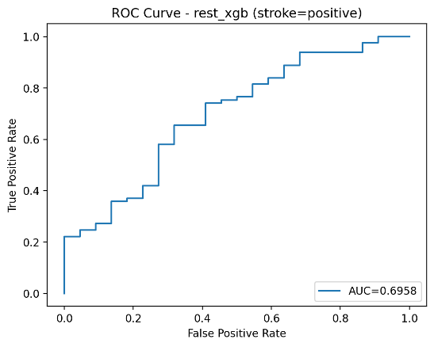

Figure 2. Receiver Operating Characteristic (ROC) Curves Across Combined and Cohort-Specific Evaluations
Receiver operating characteristic (ROC) curves for stroke prediction models evaluated under three cohort settings. The top row shows results from the combined evaluation, in which predictions are generated for the full held-out test set following cohort-based routing. The middle row shows results for the best-performing cohort, representing a subset of test samples identified through the cohort construction process. The bottom row shows results for the remaining cohort, consisting of test samples not included in the best-performing subset. For each cohort setting, ROC curves are shown for three model types: neural network (NN), random forest (RF), and gradient-boosted tree (XGB). Stroke is treated as the positive class in all evaluations. ROC curves are generated by varying the decision threshold applied to continuous prediction scores, and the area under the curve (AUC) is reported on each panel.

Table: Performance comparison across modeling strategies (ROC-AUC)
Model | Baseline (All) | Best Cluster Only | Rest Only | Combined (Routed) | Δ vs Baseline
Random Forest | 0.865 | 1.000 | 0.753 | 0.894 | +0.029
Neural Network | 0.842 | 0.986 | 0.752 | 0.865 | +0.023
XGBoost | 0.867 | 0.970 | 0.696 | 0.840 | −0.027

Summary of area under the receiver operating characteristic curve (ROC–AUC) for three model types evaluated under different modeling strategies. “Baseline (All)” reports performance on the full held-out test set without cohort-based routing. “Best Cluster Only” and “Rest Only” report performance when models are evaluated separately on the best-performing cohort and the remaining cohort, respectively. “Combined (Routed)” reports overall performance on the full test set when predictions are generated using cohort-based routing. Δ vs Baseline indicates the absolute difference in ROC–AUC between the combined routed evaluation and the baseline evaluation for each model.

